Prove It! Online response rates

Prove It uses web based links to collect responses from a range of participants for each different Prove It tool and voice. Response rates can be lower for online evaluations than for other ways of collecting responses. However, collecting data this way means that we are able to monitor responses, minimise and manage invalid responses and automatically analyse responses. This reduces the load on professionals to design questions, collect and analyse data. Through Prove It! your data is analysed and centrally held, and organised to reflect the impact data across the Balanced System 5 Strands and 3 levels.
This information sheet is designed to support you in increasing your response rate, based on research and practical experience gained through our pilot sites using the tools.
Here are some ideas from the research that may help you to increase your response rates:
- Sending a follow-up/ reminder invite within 1 week of the first invitation supports an increased response rate.
- Sending personalised follow-up reminders, for example “Hi this is Sarah from the Advice line, we really value your feedback and hope the advice line was helpful. Let us know your thoughts using this link thanks. You can do this from within the “Share” function in “My Prove Its!”.
- Consider when you send out any follow up reminders. Some research has shown that surveys sent out at the start of a week, especially Mondays, have a higher response rate compared to being sent towards the end of the week.
- Follow up phone calls to support families to complete part 2 responses have supported one pilot area to increase their follow up response rate.
- For some families, online access can be difficult. You can print copies of the questions and encourage families to complete in written form. You can access pdf versions of the questions and input this information within your account, using the links within the “Share” function in “My Prove Its!”

How to use the Prove It! Functions to increase response rates:
- Within the “share” function, you will find a link to send follow up or reminder emails:
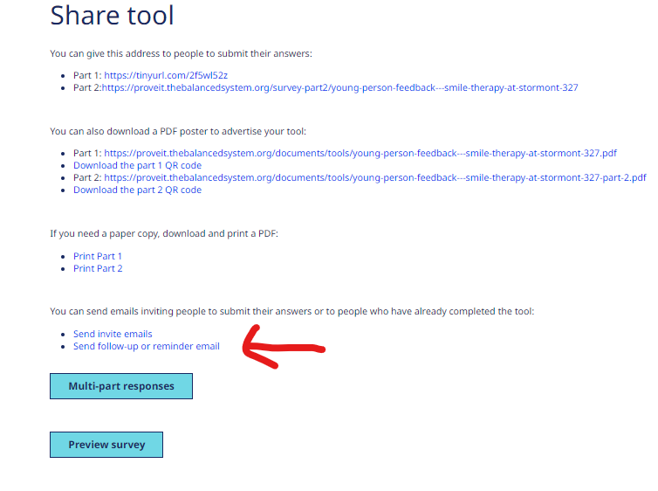

You can select who you send this to and personalise your email to encourage respondents based on your knowledge of how and why their reply is needed
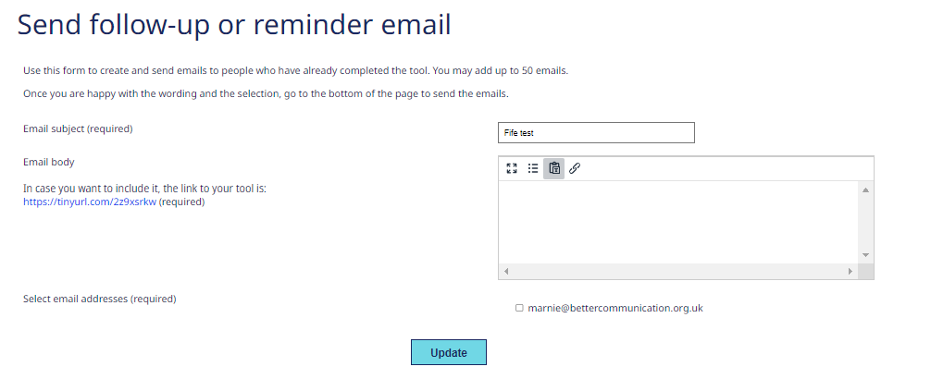
- Alternatively, you can contact individual respondents to request a part 2 response. Within the “share” function, you will find “multipart responses”
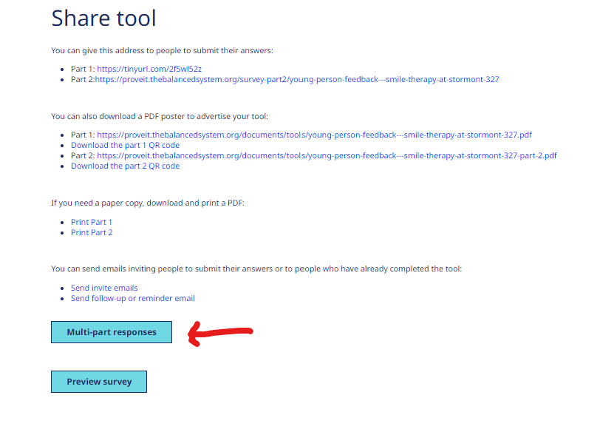

Then “Send Part 2 email
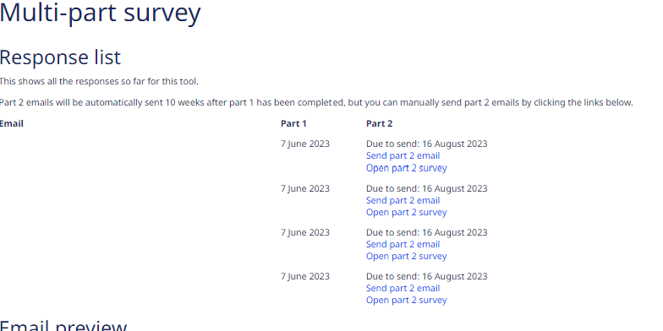

Planning for your Prove It! Account
What do you want to prove?  High Level Outcomes | What do you want to prove?  KPIs linked to outcomes | Service development and management data required  Consider:  What kind of data will you need?  What will you use this data for?  How will it help? | Data about settings, workforce to prove this outcome  Consider:  What kind of data will you need?  What will you use this data for?  How will it help? | Data about individual school / hub / child to prove this outcome  Consider:  What kind of data will you need?  What will you use this data for?  How will it help?

